



**Project:** Hate Speech Detection using Transformers (Deep Learning)

**Week 11:** Deliverables

**Name:** Anitha Venkatachalam **Email:** [anitha.Venkat83@gmail.com](mailto:anitha.Venkat83@gmail.com) **Country:** Canada

**Specialization:** Data Science **Batch Code:** LISUM14

**Date:** 22Nov 2022

**Submitted to:** Data Glacier

**Table of Contents:**

1. Project Plan 3
2. Problem Statement 3
3. Data Collection 3
4. Data Preprocessing 4
   1. Text Cleaning 4
      1. Lower Case 4
      2. Remove Punctuation 4
      3. Remove URL 4
      4. Remove @tags 4
      5. Remove Special Characters 4
   2. Preprocessing Operations 4
      1. World Cloud 4
   3. Feature Extraction 5
      1. TF-IDF Model 5
   4. Split the Dataset into Train and Test 6
5. Build the Model 6

5.2.1Logistic Regression with TF-IDF on N-Grams 6

1. Result Evaluation 6

6.1Evaluation Criteria 6

7.Application Design 7

7.1. Turning ML model Into Flask Framework 8

7.2. Running Procedure 9

8.Conclusion 10

**Project Plan**

|  |  |  |
| --- | --- | --- |
| **Weeks** | **Date** | **plan** |
| **Weeks 07** | **Nov 14th, 2022** | **Problem Statement, Data** |
|  |  | **Collection, Data Report** |
| **Weeks 08** | **Nov 21, 2022** | **Data Preprocessing (Text** |
|  |  | **Cleaning)** |
| **Weeks 09** | **Nov 28, 2022** | **Data Preprocessing** |
|  |  | **(Preprocessing Operation +** |
|  |  | **Feature Extraction)** |
| **Weeks 10** | **Dec 5, 2022** | **Building the Model** |
| **Weeks 11** | **Dec 12, 2022** | **Model Result Evaluation** |
| **Weeks 12** | **Dec 19, 2022** | **Flask Development + Heroku** |
| **Weeks 13** | **Dec 26, 2022** | **Final Submission (Report +** |
|  |  | **Code + Presentation)** |

1. **Problem Statement**

The term hate speech is understood as any type of verbal, written or behavioral communication that attacks or uses derogatory or discriminatory language against a person orgroup based on what they are, in other words, based on their religion, ethnicity, nationality, race, color, ancestry, sex or another identity factor. In this problem, we will take you through a hate speech detection model with Machine Learning and Python.

Hate Speech Detection is a task of sentiment classification. So, for training, a model that can classify hate speech from a certain piece of text can be achieved by training it on a data that is used to classify sentiments. So, for the task of hate speech detection model, we will use the Twitter tweets to identify tweets containing Hate speech.

1. **Data Collection**

The Data is about Twitter hate Speech taken from Kaggle [1] which contains the 3 number of features and 31962 number of observations. Dataset using Twitter data, it was used to research hate-speech detection. The text is classified as: hate-speech, offensive language, and neither. Due to the nature of the study, it is important to note that this dataset contains text that can be considered racist, sexist, homophobic, or offensive.

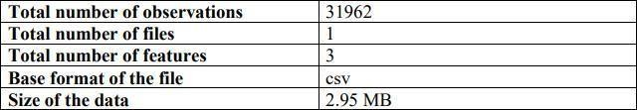**Table 1: Data Information**

3

1. **Data Preprocessing**

In part, we explain the data preprocessing approach that we apply in the text data.

* 1. Text Cleaning

First, we clean our text because it was so messy data.

* + 1. Lowercase

Converting a word to lower case (NLP -> nlp). Words like Racism and racism mean the same but when not converted to the lower case those two are represented as two different words in the vector space model (resulting in more dimensions). Therefore, we convert all text word into lower case letter.

* + 1. Remove Punctuation

It is important to remove the Punctuation because is not important. Therefore, we remove that Punctuation in order to do that we use regular expression.

* + 1. Remove URLs

In this part, we remove URLs because we are working on hate speech application which detect the hate and free speech and to get the output, we need to give only text not URLs therefore, we remove the URLs because we need only clean text input.

* + 1. Remove @tags

In this part, we remove @tags which basically used when we mentioned someone So, it’s doesn’t concern to our application therefore, we remove @tags by using regular expressions. 4.1.5 Remove Special Characters

Remove Special Characters is essentially the following set of symbols [!”#$%&’()*+,-

./:;<=>?@[]^_`{|}~] which basically don’t have meaning. Therefore, we remove that kind of symbols because we don’t need that**.**

4

* 1. **Preprocessing Operation**

**In this part, we implement the preprocessing operation**

* + 1. **Word Cloud**

**A Word cloud is a visual representation of text data, which is often used to depict keyword metadata on websites, or to visualize free form text. Tags are usually single words, and the importance of each tag is shown with font size or color.**

* 1. **Feature Extraction**
     1. **TF-IDF Model**

**Once the dictionary is ready, we apply Term Frequency-Inverse Document Frequency (TF-IDF) model, and we take 2000 most frequent words from dictionaries for each Hate/Free Speech of the whole dataset. Each word count vector contains the frequency of 2000 words in the whole dataset file.**

* + 1. **Split the Data into Train into Test**

**In this part, we split the data into Train. And we split 80% for training and 20% for test. Data splitting is when data is divided into two or more subsets. Typically, with a two-part split, one part is used to evaluate or test the data and the other to train the model. Data splitting is an important aspect of data science, particularly for creating models based on data.**

5

**5.2 Build the Model**

**5.2.2Logistic Regression with TF-IDF on N-Grams**

This process explains how to run a classification algorithm and more specifically a logistic regression of a “The hate and free speech detection on twitter” using as features the TD-IDF of unigrams, bi-grams, and trigrams. We can easily apply any classification, like Random Forest, Support Vector Machines etc. Finally, it finds whether the text is hated speech or free speech. logistic regression:

Logistic regression is a supervised machine learning method which is like linear regression but instead of using a linear equation it uses a sigmoid function which makes the output value in specific range which is used for text classification also Hate Speech Detection

in Twitter using Natural Language Processing.

# 6.1 Evaluation Criteria

The confusion matrix was used to evaluate the classification models throughout the training process. The confusion matrix is a table that compares predicted and actual outcomes. It is frequently used to describe a classification model's performance on a set of test data.

Table 1: Confusion Matrix

|  |  |  |
| --- | --- | --- |
| **Class** | **Predicted Negative** | **Predicted Positive** |
| Actual Negative | TN | FP |
| Actual Positive | FN | TP |

Important metrics were constructed from the confusion matrix in order to evaluate the classification models. In addition to the accurate classification rate or accuracy, other metrics for evaluation included True Positive Rate (TPR), True Negative Rate (TNR), False Positive Rate (FPR), False Negative Rate (FNR), Precision, F1 score, and Misclassification rate.

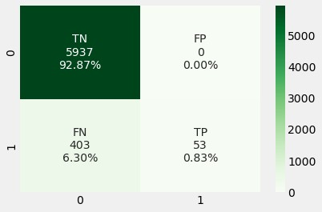

Below table shows the result that we evaluate based on confusion matrix result

Table : Results

|  |  |  |  |  |  |  |  |
| --- | --- | --- | --- | --- | --- | --- | --- |
| **Classifiers** | **Accuracy** | **Precision** | **TPR** | **FPR** | **F1**  **Score** | **Error Rate** | **Specificity** |
| CNN with LSTM | 0.9577 | 0.8382 | 0.4191 | 0.0055 | 0.5588 | 0.0422 | 0.9944 |
|  |  |  |  |  |  |  |  |

Below you can see the visualization result of above table as well.

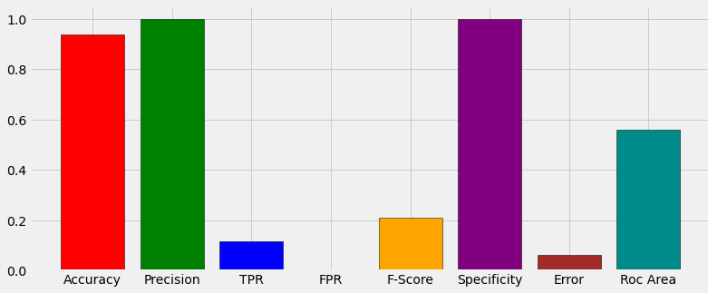

6

## **Application Design**

In this chapter, we develop a Model & Deploy It with Flask. Our model systems workflow is like this: Train offline -> Make model available as a service -> Predict online.

* + A classifier is trained offline with Fake and True news.
  + The trained model is deployed as a service to serve users.

**5.1 Turning Model into a Web application:**

First, we use the twitter hate speech dataset to build a prediction model that will accurately classify hate speech. We develop a web application that consists of a simple web page with a form field that lets us enter a message. After submitting the message to the web application, it will render it on a new page which gives us the result of hate speech/free speech.

**5.2. Running Procedure**

Once we have done all of the above, we can start running the API by either double click *app.py*, or executing the command from the Terminal:

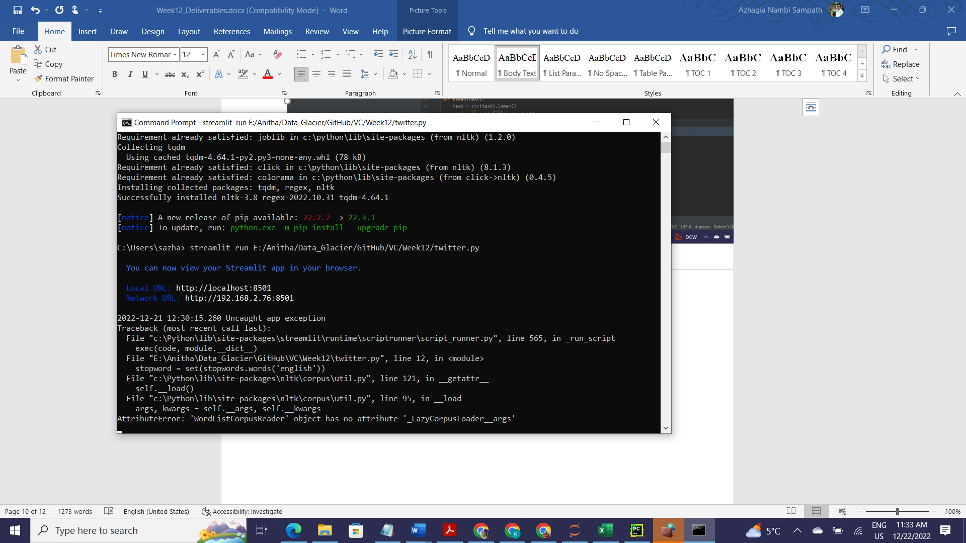

Now we could open a web browser and navigate to <http://localhost:8501> we should see a simple website with the content like so

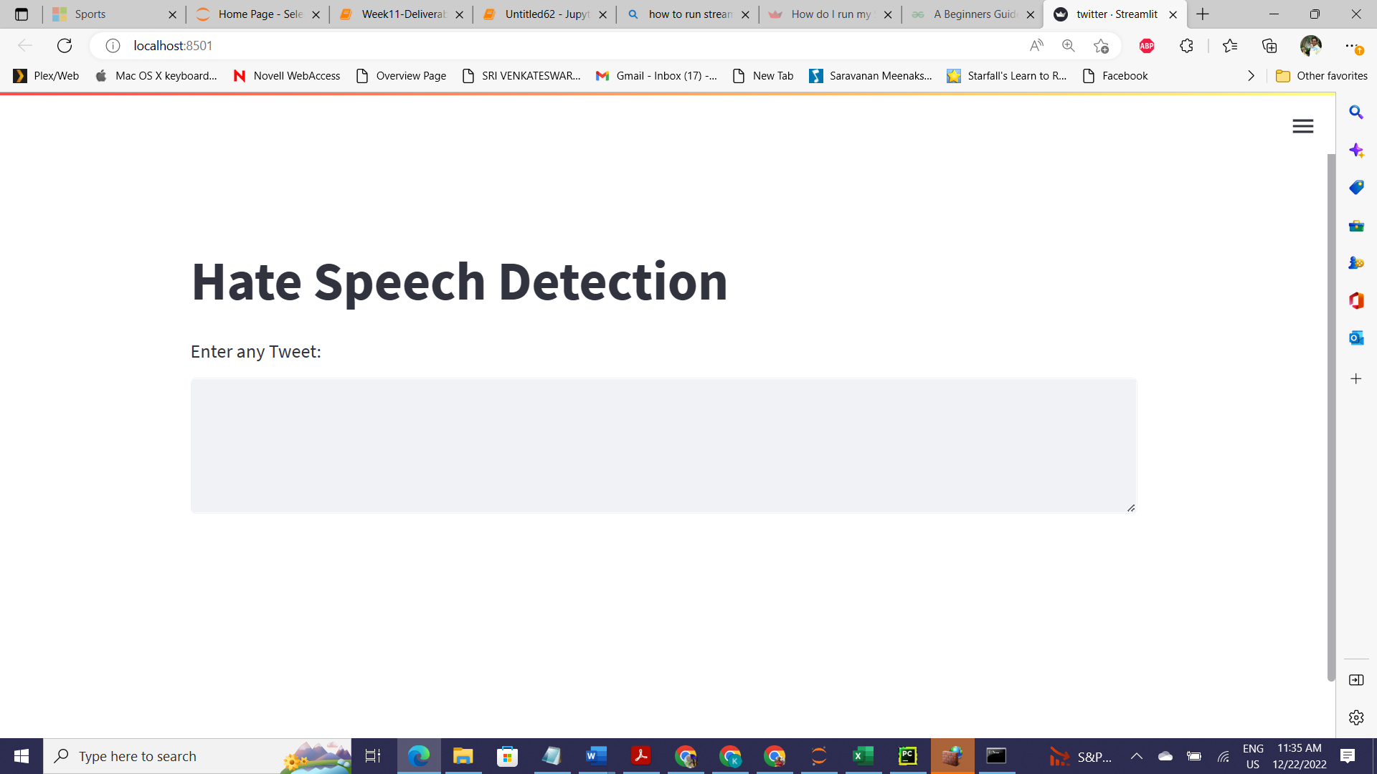

Now we enter input in the comments form

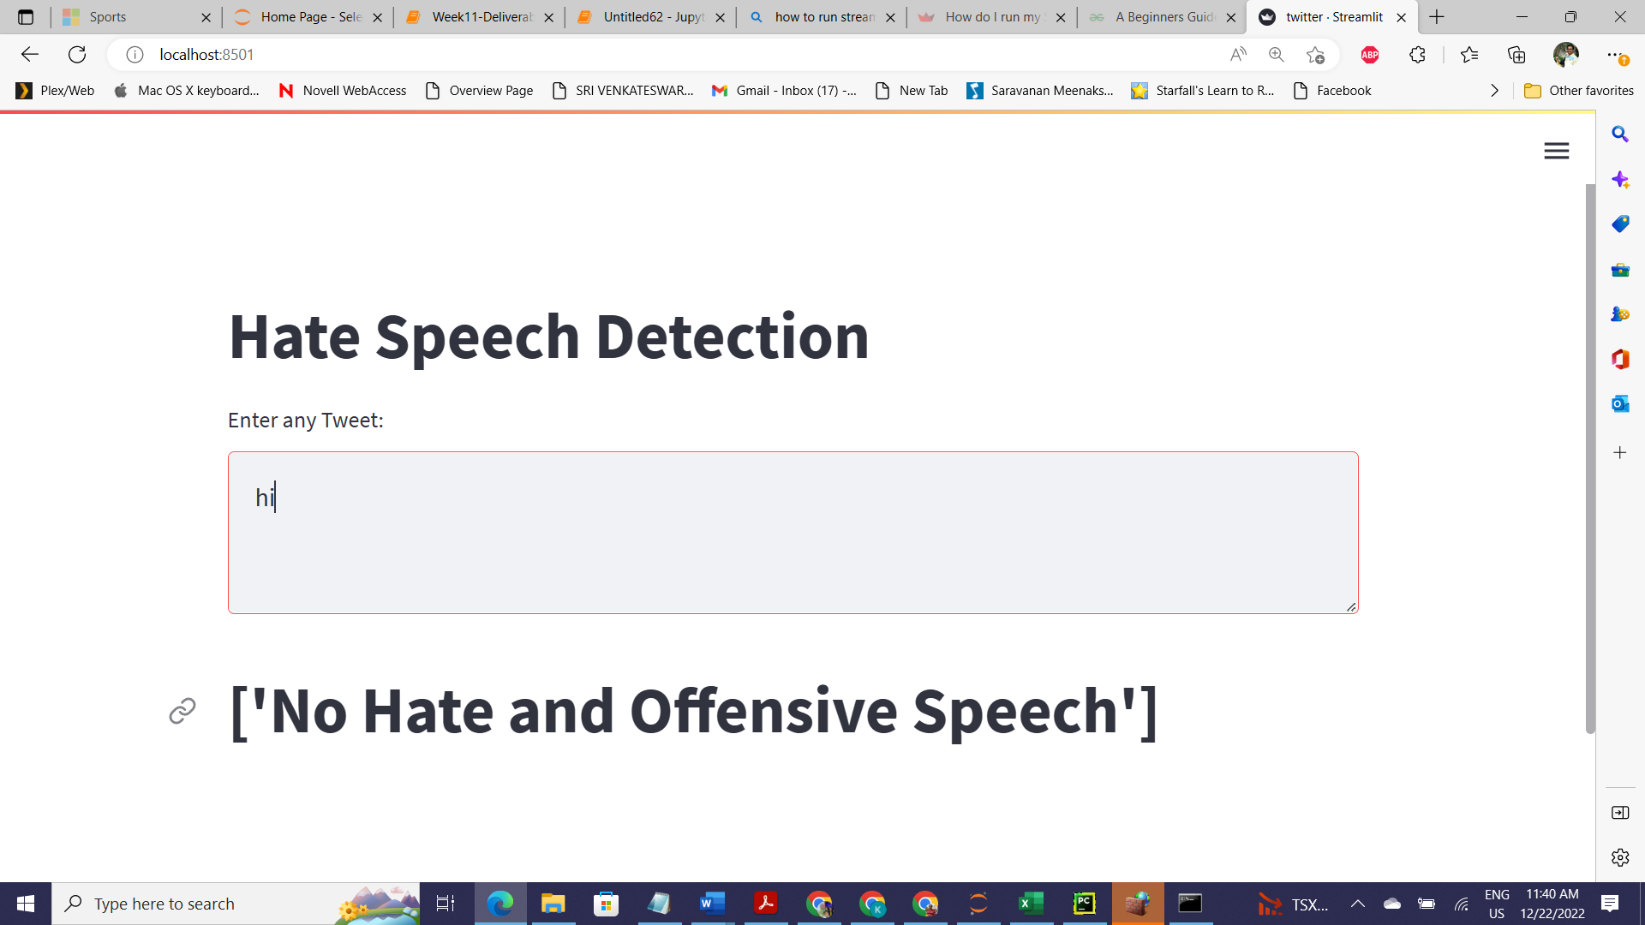

After entering the input click the predict button now we can the result of our input.

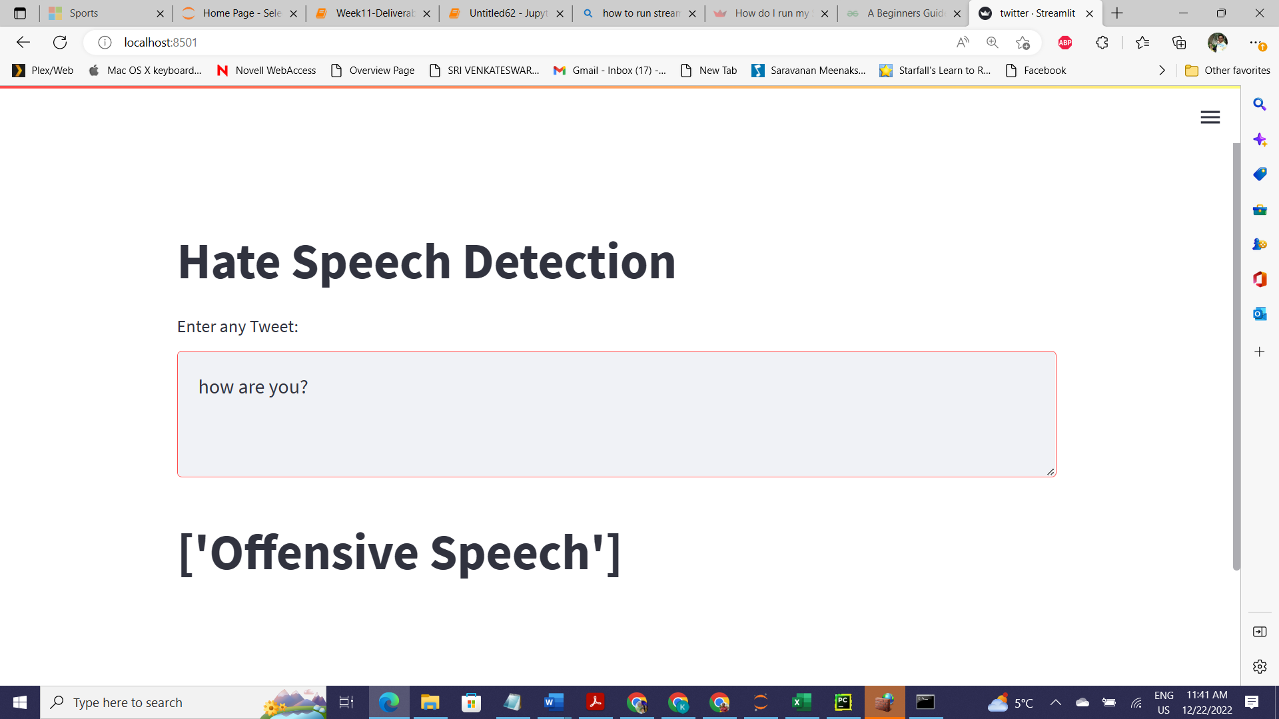

1. **Conclusion**

The goal of this project was to find capable methods and settings that could be used to help

the detection of Hate and Free Speech of twitter. The error rate of the model is not zero, so still, some incorrect can be classified as true by the model. In future we will enhance this work by implementing Temporal Convolutional Network (TCN) and Random Multimodal Deep Learning (RMDL) Techniques.

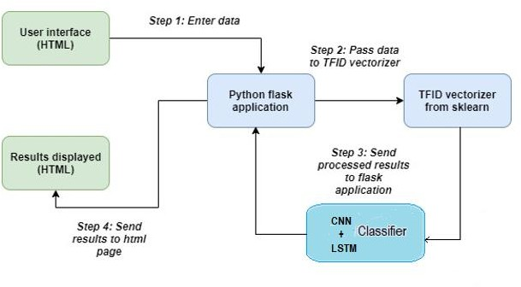





7